In this edition of spotlight we discover how the emerging exosome field is impacting stem cell science.

By Dr Michael Jones,CEO of Cell Guidance Systems.

Cell Guidance Systems manufactures and supplies growth factors, small molecules and the Pluripro® culture system for the confluent growth of human pluripotent cells. The company also recently introduced the SINEUP™ gene expression technology for knock-up of endogenous genes and offer karyotyping services.

Over the past decade, extracellular vesicles have become recognized as important mediators of intercellular communication, regulating a wide range of biological processes. The three main classes of extracellular vesicles, which are 40-2000nm in diameter and characterized by a lipid bilayer are exosomes, microvesicles and apoptotic bodies. Exosomes are small membrane-bound vesicles around 40-120nm across (figure 1). In contrast to microvesicles and apoptotic bodies, which are generated by budding from the plasma membrane, exosomes are derived within the cell from the endolysosomal pathway. Exosomes are actively secreted from cells and accumulate in high numbers in all biological fluids. Typically, blood contains 10¹²exosomes per ml. Lower concentrations are found in other bodily fluids. Exosomes also accumulate in conditioned cell culture media which after two days exposure to cells contains around 10⁶-10⁸ exosomes per ml, depending on the cultured cell type.

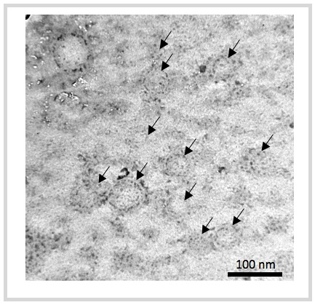

Figure 1: Exosomes (arrowed) viewed under transmission electron microscope
Secreted exosomes carry a cargo which includes proteins and lipids, as well as coding and non-coding RNA molecules, which are representative of their cells of origin. Although some of this cargo may be non-specific, there is mounting evidence for enrichment of certain RNA species. Exosomes released by one cell can fuse with adjacent or distant cells and transfer their cargo exerting a paracrine effect.
The unique properties and characteristics of exosomes have lead to a sharp increase in research activity in recent years. 2013 is on course to see a doubling in the number of exosome papers compared with 2012 (see figure 2).

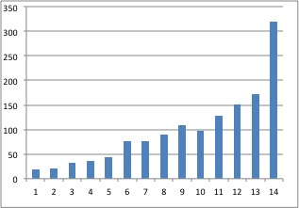

Figure 2: Exosome publications are surging reflecting the growing interest in the field. 2013 numbers extrapolated from publications to date.
Many labs working with exosomes are focusing on the analysis of protein and RNA cargo for potential utility in diagnostics. Cancer is just one of a range of diseases that are being studied by profiling the contents of exosomes present in the blood of patients. RNA species that are specifically elevated in exosomes isolated from blood have been identified for a range of cancers.
It is becoming clear that exosomes play an important role the aetiology of a wide range of disease. For example, exosomes released by stromal cells have been shown to contribute to the metastatic spread of breast cancer. The capacity of exosomes, which can cross the blood brain barrier, to deliver a protein or RNA cargo has generated interest in their potential use in gene therapy and drug delivery.
A strong paracrine capacity has been proposed as the principal mechanism by which mesenchymal stem cells (MSCs) encourage tissue repair. Extracellular vesicles that are derived predominantly from stem cells can induce angiogenesis in non-dividing endothelial cells, suppressing apoptosis and stimulating cell proliferation. Exosomes from stem cells can recruit and reprogramme cells that are required for tissue regeneration as well as deliver immunomodulatory signals. For example, specific miRNA cargo molecules, secreted by MSCs, have been identified which are associated with remodeling of target neuronal cells. In addition, in a separate study, transplanted CD34+ cells have been shown to secrete miRNA containing exosomes which augment regenerative efficacy for ischemic tissue repair.
Little is known about how exosomes may be contributing to the maintenance of cell culture systems. Perhaps exosome supplements may be used to improve the quality of cell culture? For example, exosome preparations derived from one cell line may enable or promote reprogramming of an independent cell line.

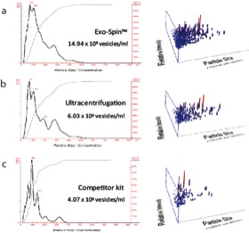

Figure 3 Exo-spin™ generates higher yields. Nanosight™ analysis of exosomes purified from conditioned medium using ultracentrifugation and competitor kits.

Efficient purification of exosomes has been problematic. This is required for their analysis and for the development of exosome-based technologies. At present, protocols based on ultracentrifugation are by far the most widely used. Commercially available precipitants for the preparation of exosomes have eliminated the need for ultracentrifugation but have not become widely used due to significant drawbacks in terms of purity and yield of the preparation. These products also suffer from remnants of precipitant, which are not removed from the final preparation. To address these issues, Cell Guidance Systems will soon be launching Exo-spin™, a spin column based exosome purification kit based on technology exclusively licensed from A*STAR in Singapore. Exo-spin™ generates superior yields and higher quality whole exosomes than any available alternative technology (figure 3). No ultracentrifugation is required and the kits are very cost effective.
The first of a range of Exo-spin™ kits that will allow preparation of exosomes from biological fluids including urine, saliva and blood and from cell culture will be launched in August 2013

